Declaration to Join the
Coalition of Inclusive Municipalities

Given that:
1 The Canadian Commission for UNESCO (United Nations Educational, Scientific and Cultural Organization) is calling on municipalities to join a Coalition of Inclusive Municipalities and to be part of UNESCO’s international Coalition launched in 2004; and

2. The Federation of Canadian Municipalities (FCM) endorses the Call for a Coalition of Inclusive Municipalities and encourages its members to join; and

Whereas:
3. Municipal governments in Canada, along with other levels of government, have responsibilities under Canada’s Charter of Rights and Freedoms as well as federal, provincial and territorial human rights codes, and therefore have an important role to play in combating racism and discrimination and fostering equality and respect for all citizens;

Be it resolved that:
4. The insert the name of the municipality agrees to join the Coalition of Inclusive Municipalities and, in joining the Coalition, endorses the Common Commitments and agrees to develop or adapt its own unique Plan of Action accordingly.

5. These Common Commitments and the Municipality’s unique Plan of Action will be an integral part of the Municipality’s vision, strategies and policies.

6. In developing or adapting and implementing its own unique Plan of Action toward progressive realization of the Common Commitments, the Municipality will cooperate with other organizations and jurisdictions, including other levels of government, Indigenous peoples, public and private sector institutions, and civil society organizations, all of whom have responsibilities in the area of human rights.

7. The Municipality will set its priorities, actions and timelines and allocate resources according to its unique circumstances, and within its means and jurisdiction. The Municipality will exchange its expertise and share best practices with other municipalities involved in the Coalition and will report publicly on an annual basis on actions undertaken toward the realization of these Common Commitments.

Insert name of the Municipality, insert date (month day, year)

His/Her Worship insert name of the mayor

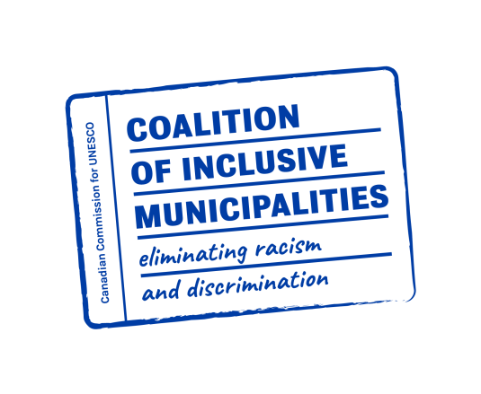
SIGNATURE OF THE MAYOR

